1811ICT/2807ICT/7001ICT Programming Principles Workshop 7

School of Information and Communication Technology

Griffith University

|  |  |
| --- | --- |
| Goals | This workshop focusses on lists, indexing, slices, list methods, and/or tuples. |
| When | Week 8 |

# Before your workshop class:

* Read the whole document.
* Review the lecture notes sections 1 to 17.
* **Complete the pre-workshop questions posted on the course website**.

# Workshop activities

At any stage, when you are stuck, *ask your workshop instructor*!

1. **Problem 1**

*Problem:* Write a program that reads strings (without digits or symbols in the string) typed by the user until an empty string is entered. For each string, convert all words to lowercase, then sort and print the words into descending order lexicographically. Hint: use split function to split a string into a list, then sort it with a method.

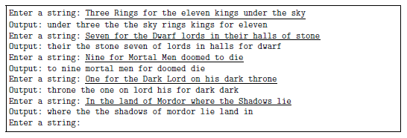

*Testing*: Test your code with the example output above.



How would you change the code above to first read in all the strings until an empty string is entered? Think of two different approaches.

If you haven’t done it already, change your code by writing your own function to sort a string after splitting the words.

1. **Problem 2**

*Problem:* Write a program that allows the user to enter two lists of integers, calculate the sum of the first and the last integers in each list, and print the larger sum. In the event of a tie, print ‘Same’. When there is only one integer in the list, the sum is the integer itself.

*Example input and output:*

List 1: 1 2 3 4 5

List 2: 5 6 7

Output: 12

List 1: 4 3 10 1

List 2: 9

Output: 9

List 1: 4 3 2 1

List 2: 1 2 3 4

Output: Same

*Testing*: Test your code with the example output above.



What do you need to change to let the code work for floating point numbers (floats)?

Did you test for negative numbers?

1. **Problem 3**

*Problem:* We’ll say that a lowercase ’g’ in a string is ”happy” if there is another ’g’ immediately to its left or right. Write a function to print ‘HAPPY’ if all the g’s in the given string are happy, otherwise, print ‘LONELY’.

*Example input and output:*

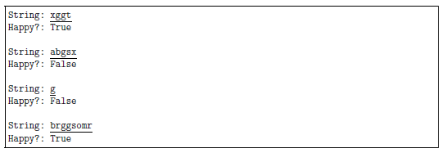

*Testing*: Test your code with the example output above.



Rewrite your function to return 2 values, namely the string and the result. You cannot use a list. What else will you use?

Did you also test your code for an empty string as input?

1. **Problem 4**

*Problem:* Write two functions. The one function converts degrees in Celsius to degrees in Fahrenheit. The other function converts degrees in Fahrenheit to degrees in Celsius. Each function must return both values (you cannot use a list).

The following formulas/equations can be used for the conversion:

*Example input and output:*

Enter the degrees and the unit (C/F): 100F

100F is 37.78C

Enter the degrees and the unit (C/F): 35 C

35C is 95F

Enter the degrees and the unit (C/F): 20,F

20F is -6.67C



What do you observe with the input? You need to be able to manage different ways a user may enter the information. What will be the easiest way to do this? Can you search for something specific in the string?

1. **Problem 5**

*Problem:* Write a program that allows the user to enter the marks of 5 students in 4 courses, and outputs the highest average marks for students and courses. Hint: Consider 2 dimensional lists, i.e. the element of a list is a list.

*Example input and output:*

Student 1 (courses 1-4): 50 60 70 60

Student 2 (courses 1-4): 100 90 87 90

Student 3 (courses 1-4): 70 100 90 90

Student 4 (courses 1-4): 30 65 50 50

Student 5 (courses 1-4): 58 50 74 43

The highest average mark of students: 91.75

The highest average mark of courses: 74.2

*Testing*: Test your code with the example output above.



Did you also test for negative values? How would you deal with negative values?

1. **Problem 6**

Go back to the sheets of the workshops and change the problems indicated below using tuples or lists, and functions to solve the problems. Instead of printing multiple values as you did before, let a function do the calculations and return those values. The returned values can then be printed.

* Workshop 2: Problems 1, 2, 3
* Workshop 3: Problems 4
* Workshop 4: Problems 1, 3
* Workshop 5: Problems 1, 2, 3
* Workshop 6: Problems 4, 5, 6.



What are the advantages and disadvantages of the two approaches, i.e. the one you used before and the new one using tuples/lists and functions? When will you use a tuple and when will you use a list?

When will you use a tuple and when will you use a list?



Well done for finishing these activities!